MIDTERM EXAMINATION
TIME ALLOWED: 90’ Subject: Linear Algebra.
No Book and Laptop allowed

1/ a/ Solve the equation 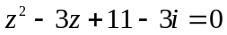.
b/ Compute 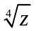, given that 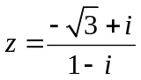.

2/ Find the matrix X such that 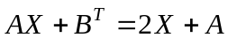, given that
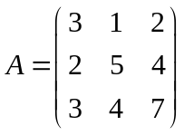, 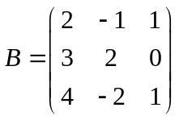.

3/ Determine all real value(s) m, such that the matrix

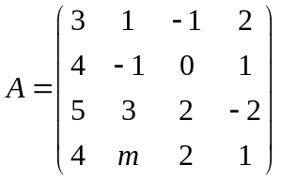 is invertible.

4/ Solve the following system of linear equations
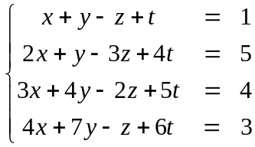

5/ Given the system of linear equations: 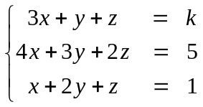.
a/ Describe the geometrical relationship of the three planes represented by this system of equations.

b/ Find the set of values of k for which the following system of equations has infinitely many solutions.

6/ Determine all value(s) m such that the set 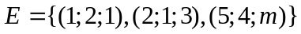 is a basis for 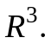

7/ Let 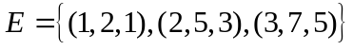 and 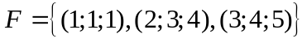be two bases for 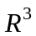.
Find the coordinates of the vector with respect to 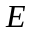,given that 

